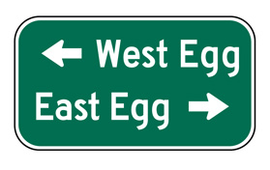
Setting: West and East Egg Chapter 1

Essential Question: What do Fitzgerald’s language choices tell the reader about East and West Egg?

Instructions: Read from the bottom of page 7-8. Identify the adjectives, nouns, and verbs that are associated with each location. When done, answer the essential question.

West Egg | East Egg
Ex. imitation | Ex. white palaces
What do Fitzgerald’s language choices tell the reader about East and West Egg?

