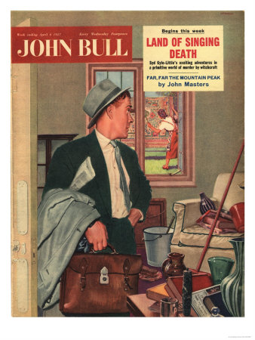

**Space in the frame**

**Staple features for Analysis**

Context

Purpose

Audience

Mood or Tone

Theme/Message

**Color Contrast**

**Character positioning**

**Color Symbolism**

Features and Conventions of a Visual Text

**Use of eye contact to create mode of address**

**Font Size and style**

**Foreground**

**Background**

**Subject**