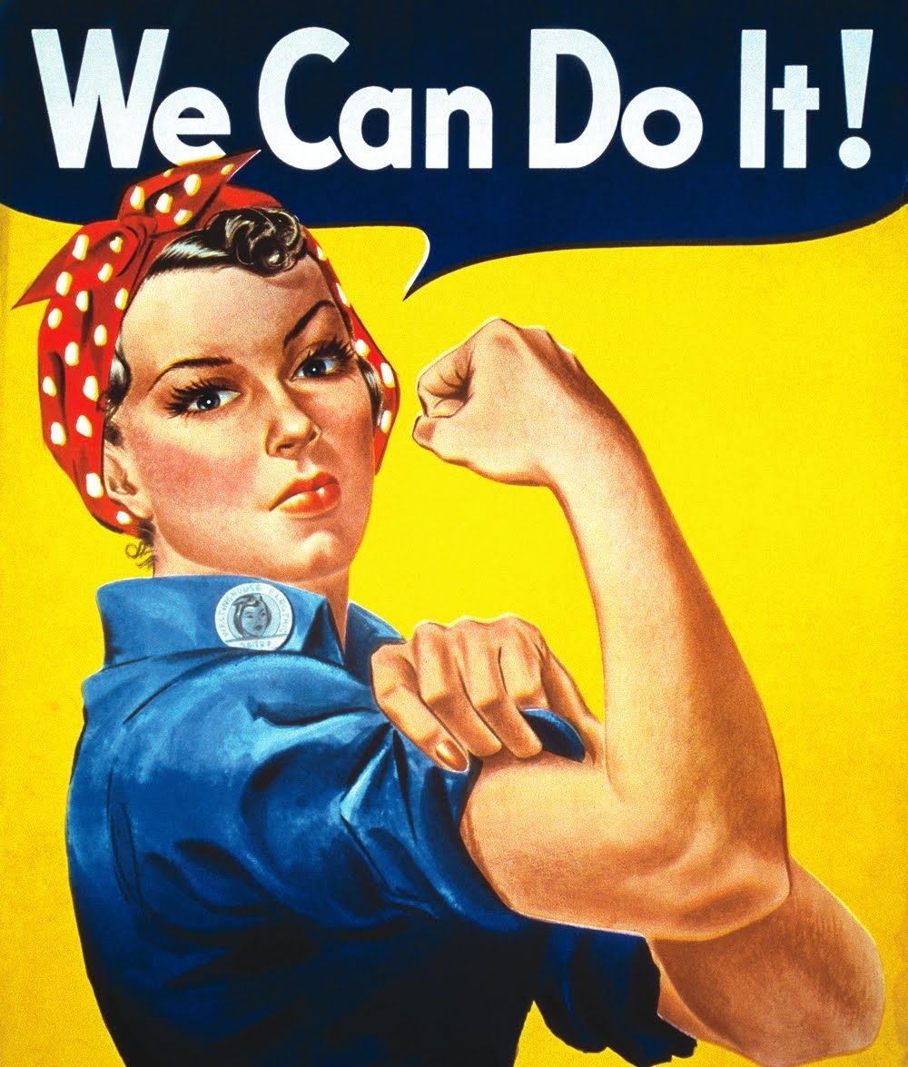
Image Analysis

Another text that could appear on an IB Paper 1 examination is an image that may or may not include any text.

Step 1: Observations and Speculations
Visual analysis is partly technical but also highly reflective and subjective. Spend some time observing the image before diving into analysis.
What tools and techniques are employed to convey the message of the image?

Subject: Who or what is the subject? Describe.
Initial Observations: Literally, what do you see in the image?
Speculations: What could the image be implying?

Step 2: Initial Analysis
Like all of the texts we have been analyzing, you will have to identify the context, purpose, audience, mood, tone and diction of the image.

 | Questions to Consider | Identify and Explain
Context | What is important about the time period, physical location, or social issues surrounding the image?
Purpose | What is the purpose of the image? Often this links to the context.
Audience | To whom would this image appeal? For whom is this image meant? Often this links to the context.
Mood (atmosphere) | How does the intended audience feel when looking at the image? Often this links to the implied meaning and context. Choose mood OR tone.
Tone/Diction | Think about the creator/artist/publisher of the image. What is his/her attitude towards the subject? How do the word choices contribute to this attitude? Often this links to the context and purpose. Choose mood OR tone.

Step 3: Image Features Analysis
After the initial analysis, begin to look at the features of an image. Make connections between the features and the intended purpose or message of the image.

 | Questions to Consider | Identify and Explain
Characterization | How are people portrayed in the images? How is culture portrayed through the characters? Do the characters represent different races, genders or ethnicity? Explain the effects of the characters.
Foreground | What do your eyes notice first? Why? How is the building, landscape, setting structured? Which images are located in the foreground? What effect does the placement have on the image?
Background | Which images are located in the background? What effect does the placement have on the image?
Font:  Size and Color | If applicable, what type of font is used? Does the size or color of the font contribute to the overall meaning of the words? Explain.
Light and Color | What colors are used in the images? What colors do your eyes see first? How is light used? Does this use of color or light have symbolic meaning?

Step 4: Big Idea
Finish your analysis with a big idea statement. After considering all of your analysis, what is the overall message being conveyed? Write it in a complete sentence.

Big Idea Statement

