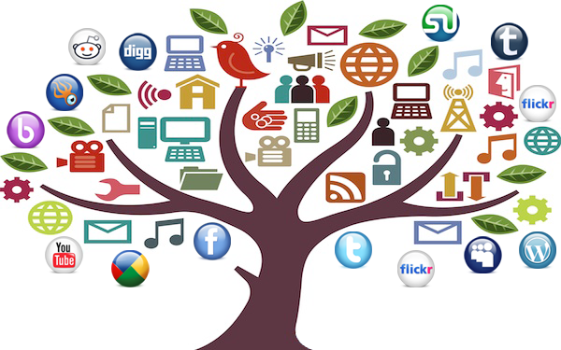
Key Concepts for Media Literacy
- Media are constructions
Media products are created by individuals who make conscious and unconscious choices about what to include, what to leave out and how to present what is included. These decisions are based on the creators’ own point of view, which will have been shaped by their opinions, assumptions and biases – as well as media they have been exposed to. As a result of this, media products are never entirely accurate reflections of the real world – even the most objective documentary filmmaker has to decide what footage to use and what to cut, as well as where to put the camera – but we instinctively view many media products as direct representations of what is real.
- Who created this media product?
- What is its purpose?
- What assumptions or beliefs do its creators have that are reflected in the content?
- Audiences negotiate meaning
The meaning of any media product is not created solely by its producers but is, instead, a collaboration between them and the audience – which means that different audiences can take away different meanings from the same product. Media literacy encourages us to understand how individual factors, such as age, gender, race and social status affect our interpretations of media.
- How might different people see this media product differently?
- How does this make you feel, based on how similar or different you are from the people portrayed in the media product?
- Media have commercial implications
Most media production is a business and must, therefore, make a profit. In addition, media industries belong to a powerful network of corporations that exert influence on content and distribution. Questions of ownership and control are central – a relatively small number of individuals control what we watch, read and hear in the media. Even in cases where media content is not made for profit – such as YouTube videos and Facebook posts – the ways in which content is distributed are nearly always run with profit in mind. What is the commercial purpose of this media product (in other words, how will it help someone make money)?
- What is the commercial purpose of this media product (in other words, how will it help someone make money)?
- How does this influence the content and how it’s communicated?
- If no commercial purpose can be found, what other purposes might the media product have (for instance, to get attention for its creator or to convince audiences of a particular point of view).
- How do those purposes influence the content and how it’s communicated?
- Media have social and political implications
Media convey ideological messages about values, power and authority. In media literacy, what or who is absent may be more important than what or who is included. These messages may be the result of conscious decisions, but more often they are the result of unconscious biases and unquestioned assumptions – and they can have a significant influence on what we think and believe.

As a result, media have great influence on politics and on forming social change. TV news coverage and advertising can greatly influence the election of a national leader on the basis of image; representations of world issues, both in journalism and fiction, can affect how much attention they receive; and society’s views towards different groups can be directly influenced by how – and how often – they appear in media.
- Who and what is shown in a positive light? In a negative light?
- Why might these people and things be shown this way?
- Who and what is not shown at all?
- What conclusions might audiences draw based on these facts?
- Each medium has a unique aesthetic form
The content of media depends in part on the nature of the medium. This includes the technical, commercial and storytelling demands of each medium: for instance, the interactive nature of video games leads to different forms of storytelling – and different demands on media creators – that are found in film and TV.
- What techniques does the media product use to get your attention and to communicate its message?
- In what ways are the images in the media product manipulated through various techniques (for example: lighting, makeup, camera angle, photo manipulation)?
- What are the expectations of the genre (for example: print advertising, TV drama, music video) towards its subject?

Original Source: http://mediasmarts.ca/digital-media-literacy/general-information/digital-media-literacy-fundamentals/media-literacy-fundamentals#key

