Female Trump Supporters Just Feel More Comfortable With GOP Candidate Who’s Openly Horrible To Them

NEWS IN BRIEF August 24, 2015

MANCHESTER, NH—Describing the current Republican frontrunner’s frankness on the topic as a welcome change of pace in the crowded race, female supporters of Donald Trump told reporters Monday they simply felt more comfortable backing a candidate who is openly hostile and belittling toward them. “It’s actually pretty refreshing to have a candidate who’s willing to come right out and disrespect women to our faces, rather than trying to conceal their actual views or spin their policy stances as if they’re beneficial to women,” said Trump supporter Laura Coyle, adding that she likes how she knows exactly where she stands with the billionaire due to his straightforward style of calling her gender worthless and disgusting up front. “Sure, I gave Ted Cruz and Mike Huckabee a chance. But they just talked in circles like Washington politicians, never offering any straight talk about how they view us as inferior and undeserving of equal treatment or rights. Trump’s a straight shooter, though. What he says is what he believes, which in this case is that most women are either calculating manipulators or repulsive animals.” When polled, Trump’s male supporters indicated their approval for the candidate’s willingness to express his open disdain toward women as well.

Report: Airlines Installing Uncomfortable Bumps In Seatbacks Because It Pleases Them
NEWS IN BRIEF July 22, 2015
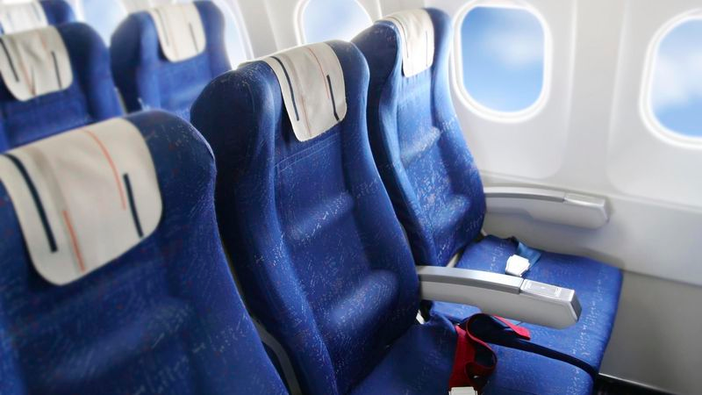

NEW YORK—According to sources throughout the commercial aviation sector, the nation’s airlines will begin installing awkwardly placed bumps in every airplane seatback this week because it reportedly brings great pleasure to them. “Over the next four to six months, across our entire fleet, we’ll be rolling out seats with an irritating array of lumps and ridges to painfully jab our customers in the back, and we couldn’t be more delighted about it,” said United Airlines CEO Jeff Smisek, speaking on behalf of all international, regional, and low-cost carriers, every one of whom admitted to deriving immense joy from watching their passengers squirm and search in vain for a tolerable position. “Let me make clear that these seats will be incredibly uncomfortable, and there is nothing more gratifying than making the experience of simply sitting during one’s flight an excruciating ordeal.” Smisek noted that for an additional fee, customers would be allowed to purchase seats with only a single, pointed protrusion in the lower back.

Modern-Day Lancelot Offers To Pay For Abortion
NEWS IN BRIEF January 28, 2015
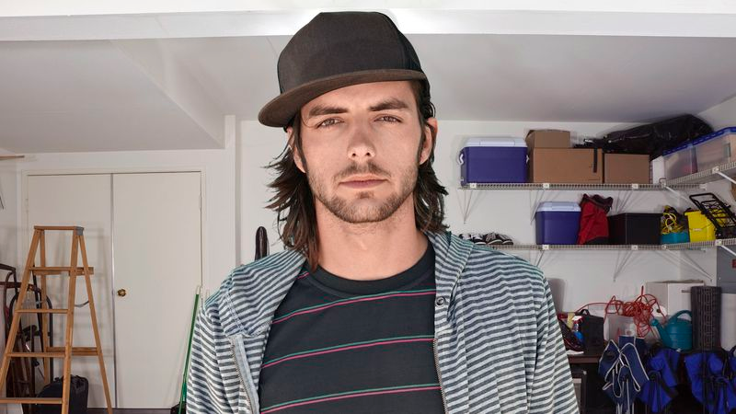

ST. LOUIS—His seed having taken hold within the loins of his beloved, modern-day Lancelot Aaron Grimaldi selflessly proffered a goodly portion of his wages Wednesday to pay for his fair lady Kelly Webster’s abortion. “You can put the whole thing on my card,” said Grimaldi, who had also gallantly ferried the maiden in his horseless carriage to their village’s Planned Parenthood clinic. “I’m going to kill some time at Best Buy. I’ll swing by in about an hour, but text me if you get done before that or if it’s gonna be a much longer thing.” At press time, Grimaldi had squired Webster to a sumptuous feast at Denny’s and was eyeing the ample bosom of a comely young wench who strode forth bearing lunch.

Man Reserving Judgment On Best Actress Nominees Until Looking At All 5 Pictures
NEWS IN BRIEF January 15, 2015

AKRON, OH—In an effort to arrive at an impartial assessment of this year’s field, area man Kurt Holden told reporters Thursday that he would postpone any judgments on the best actress Oscar nominees until he looked at all five pictures. “I’ve always liked Julianne Moore, and I think she’s fantastic in this particular picture, but to be fair I need to take the time for an in-depth viewing of each of these actresses’ pictures,” said Holden, who confirmed that he has only seen pictures of two of this year’s nominated actresses, but planned to explore the nuances and subtleties of the entire field before reaching a verdict. “I held off until the Academy revealed its choices, but now I’m actually kind of interested in checking out the Marion Cotillard picture. Who knows? I might even look at Felicity Jones’ picture two or three times.” At press time, Holden had rejected Reese Witherspoon as his selection for best actress, noting that he was bored of her picture after the first few minutes.

