Kim Jong-Un Named The Onion's Sexiest Man Alive For 2012 [UPDATE]
NEWS • North Korea • Lifestyle • ISSUE 48•46 • Nov 14, 2012
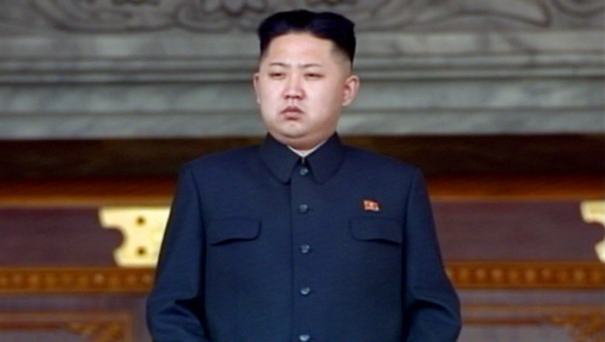

The Onion is proud to announce that North Korean supreme leader Kim Jong-un, 29, has officially been named the newspaper’s Sexiest Man Alive for the year 2012.
With his devastatingly handsome, round face, his boyish charm, and his strong, sturdy frame, this Pyongyang-bred heartthrob is every woman’s dream come true. Blessed with an air of power that masks an unmistakable cute, cuddly side, Kim made this newspaper’s editorial board swoon with his impeccable fashion sense, chic short hairstyle, and, of course, that famous smile.
“He has that rare ability to somehow be completely adorable and completely macho at the same time,” Onion Style and Entertainment editor Marissa Blake-Zweibel said. “And that’s the quality that makes him the sort of man women want, and men want to be. He’s a real hunk with real intensity who also knows how to cut loose and let his hair down.”
Added Blake-Zweibel, “Ri Sol-ju is one lucky lady, that’s for sure!”
With today’s announcement, Kim joins the ranks of The Onion’s prior “Sexiest Man Alive” winners, including:
- 2011: Bashar al-Assad
- 2010: Bernie Madoff
- 2009: Charles and David Koch (co-winners)
- 2008: Ted Kaczynski
- 2007: T. Herman Zweibel
The Onion’s commemorative “Sexiest Man Alive” issue will be available on newsstands everywhere this Friday and contains a full 16-page spread on Kim.
UPDATE: For more coverage on The Onion's Sexiest Man Alive 2012, Kim Jong-Un, please visit our friends at the People's Daily in China, a proud Communist subsidiary of The Onion, Inc. Exemplary reportage, comrades.

Source:
http://www.theonion.com/articles/kim-jongun-named-the-onions-sexiest-man-alive-for,30379/

