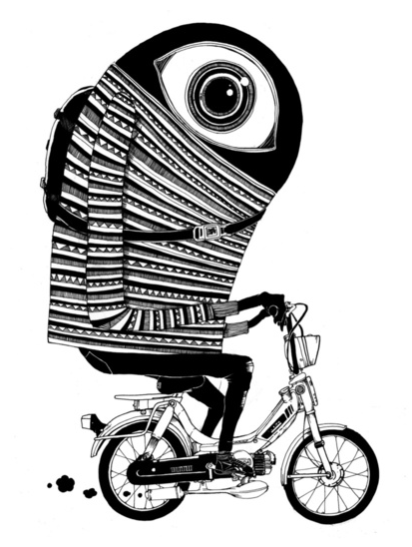
Written Task One
Guidance notes

Task requirements:
Written Task One should demonstrate your “ability to choose an imaginative way of exploring an aspect of the material studied in the course. It must show critical engagement with an aspect of a text or a topic.” (IBO, 2011) It must relate to either Part One (Language and Context) or Part Two (Language and Mass Media).
You are required to complete at least two Written Task One pieces, one of which will be submitted for external assessment.
Word limit: 800-1,000 words
Rationale: The rationale is not included in the word count (800-1,000 words) and should be 200-300 words in length.
In your rationale you must explain:
- how the content of the task is linked to a particular part of the course
- how the task is intended to explore particular aspects of the course
- the nature of the task chosen
- consideration of how audience, purpose and the varying contexts have contributed to your genre and language choices
Referencing: In text citation should be used to make direct references to source texts. A bibliography must also be provided.
Genre: Aim to choose a genre that is appropriate to the content of your Written Task material. Consider carefully how purpose and audience will impact upon your choice of genre.
Possible choices:
advertisement guide opinion column satire
biography letter parody textbook
blog magazine article pastiche travel writing
brochure/leaflet manifesto radio broadcast
editorial memoir report
interview news report speech
Language choices: It is important that you demonstrate your ability to make specific language choices based on the genre you have selected and the topic you are writing about. Ensure that you are making careful vocabulary choices and using appropriate language features and narrative devices to develop your ideas.
Process
- Choose your topic. This may come from stimulus material or discussion in class. However, you are also encouraged to pursue independent and interests linked to the course material.
- Develop your topic through research. It is important that you are reading widely and exploring a range of sources in order to have a broad perspective of your topic.
- Select a genre that will most effectively serve your purpose and intended audience.
- Find other texts of this genre so that you can identify the genre conventions: narrative perspective, register, pronoun use, language features, organisation, layout etc. How will you apply these genre conventions?
- Plan your ideas carefully. Ensure that you use examples, where relevant.
- Consult with your teacher. I can offer guidance about your ideas, organisation, genre selection etc. This may help to clarify your thinking or offer reinforcement that you are on the right track.
- Draft your first version and seek teacher feedback.
- Respond to teacher feedback and edit carefully. Remember to consult the assessment criteria, (the last page of this document).
- - - - - - - - - - - - - - - - - - - - - - - - - - - - - - - - - - - - - - - - - - - - - - - - - - - - - - - - - - - - - - - - - - - - - -
- Compose the final copy.
- Write your rationale.
It is likely that you will write more Written Task One pieces than is required for assessment. This will mean that you may not complete steps 9 and 10 every time. However, you will need to complete all steps from 1-10 for TWO pieces.
You will then submit the better of these two pieces for final assessment.

Editing checklist
In my written task, have I
Top of Form
☐ Have I stayed within the 800-1000 word limit?
☐ Have I selected a relevant title? (if appropriate)
☐ Can my topic be clearly established in the opening section of my written piece?
☐ Have I used appropriate layout and formatting for the genre that I have selected?
☐ Do my vocabulary choices reflect an appropriately sophisticated understanding of the topic? Am I using subject specific language?
☐ Is my register appropriate for my intended audience and is it consistently sustained throughout?
☐ Have I used appropriate language features throughout the piece?
☐ Are my ideas sufficiently developed through description and explanation? (if relevant)
☐ Are my ideas sequenced effectively?
☐ Does my piece show the development of my ideas?
☐ Have I used appropriate narrative devices to create cohesiveness?
☐ Have I proofread carefully to ensure that I have eliminated errors in grammar and spelling?
☐ Have I used an appropriate variety of sentence starters, structures and types for effect?
In my rationale, have I
☐ Established a connection between my piece and the course?
☐ Stated and explained the main ideas I am exploring and how I have developed them?
☐ Explicitly identified the intended audience and purpose?
☐ Explained my genre selection, language choices and narrative devices in relation to audience and purpose?
☐ Stayed within the 200-300 word limit?

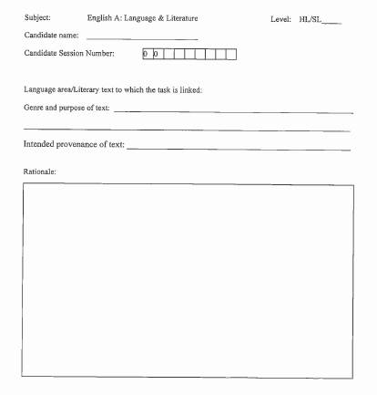
Sample Coversheet

Intended provenance: specify a publication or site in which a text such as the piece you have written could be found. The provenance of the text should be based on consideration of the intended audience.

How will Written Task One be assessed?
Remember that this is an externally assessed piece of work.
Your final grade will be a combination of your work for Written Task One and Written Task Two.
English A: Language & Literature – Written Task One Assessment Criteria (HL)
Criterion A: Rationale  • Does the rationale for the written task explain how the task is linked to the aspects of the course being investigated?  Note: The word length for the rationale is 200–300 words. If the word limit is exceeded, 1 mark will be deducted. |  | Criterion B: Task and content  • To what extent does the task show understanding of the topic(s) or text(s) to which it refers?  • How appropriate is the content to the task chosen?  • To what extent does the task show understanding of the conventions of the text type chosen?  NOTE: A formal essay, such as that produced for paper 2, is not an appropriate text type for the written task. Submission of a formal essay will limit the marks available for this criterion. |  | Criterion C: Organization  • How well organized is the task?  • How coherent is the structure?  NOTE: The word length for the written task is 800–1,000 words. If the word limit is exceeded, 2 marks will be deducted. |  | Criterion D: Language and style  • How effective is the use of language and style?  • How appropriate to the task is the choice of register and style? (“Register” refers, in this context, to the student’s use of elements such as vocabulary, tone, sentence structure and idiom appropriate to the task; register is assessed on the task itself.)  NOTE: A student who writes an appropriate rationale but fails to achieve an appropriate register in the task cannot score more than 3 marks.
0  The work does not reach a standard described by the descriptors below. |  | 0  The work does not reach a standard described by the descriptors below. |  | 0  The work does not reach a standard described by the descriptors below. |  | 0  The work does not reach a standard described by the descriptors below.
1  The rationale shows some explanation and understanding of the aspects being investigated. |  | 1-2  The task shows a superficial understanding of the topic(s) or text(s) to which it refers.  The content is generally inappropriate to the task chosen.  The task shows a superficial understanding of the conventions of the text type chosen. |  | 1  Little organization is apparent; the task has little structure. |  | 1  There is little clarity, with many basic errors; little sense of register and style.
2  The rationale shows clear explanation and understanding of the aspects being |  | 3-4  The task shows a mostly adequate understanding of the topic(s) or text(s) to which it refers. The content is generally appropriate to the task chosen. The task shows an adequate understanding of the conventions of the text type chosen. |  | 2  Some organization is apparent; the task has some structure, although it is not sustained. |  | 2  There is some clarity, though grammar, spelling and sentence structure are often inaccurate; some sense of register, style and appropriate vocabulary.
 |  | 5-6  The task shows a good understanding of the topic(s) or text(s) to which it refers. The content is mostly appropriate to the task chosen. The task shows a good understanding of the conventions of the text type chosen. |  | 3  The task is organized; the structure is generally coherent. |  | 3  The use of language and the style are generally clear and effective, though there are some inaccuracies in grammar, spelling and sentence construction; generally appropriate in register, style and vocabulary.
 | 7-8  The task shows an excellent understanding of the topic(s) or text(s) to which it refers. The content is consistently appropriate to the task chosen. The task shows an excellent understanding of the conventions of the text type chosen. |  | 4  The task is well organized; the structure is mostly coherent. |  | 4  The use of language and the style are clear and effective, with a good degree of accuracy; sentence construction and vocabulary are varied, showing a growing maturity of style; the register is appropriate.
 |  |  | 5  The task is effectively organized; the structure is coherent and effective. |  | 5  The use of language and the style are very clear and effective, with a very good degree of accuracy; sentence construction and vocabulary are good; the style is confident and the register effective.

